Enabling Multiple Java Form Sessions in Oracle Financials
Java Web Start (JWS) allows users to open multiple forms, at the same time. This is particularly useful if you wish to view two pieces of information simultaneously, e.g. PO Enquiry and Invoices Enquiry.
In order to do this, a setting needs to be enabled in the users individual preferences.
- From the Home Screen, click on the Settings cog, towards the top right corner of the page and select ‘Preferences’
- In the ‘Forms Launch’ section, tick the box next to ‘Always Launch New Forms Session’
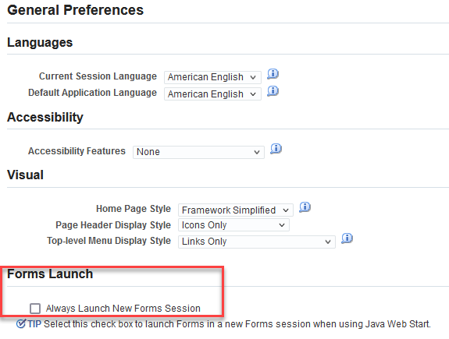
- To save the change click the button toward the top right corner of the screen. You should get notification confirming that the setting have been updated successfully.

- Click the following button to return to the Home Screen.

- Access a responsibility which opens a Java form.

- To open the second form, return to the Home Page and select the required responsibility.

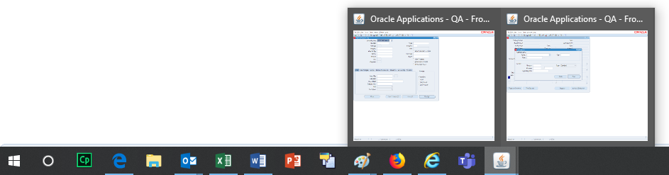
- You will now have 2 screens available from your task bar to work on at the same time.

