**Setting up browsers to open Java forms in Oracle**

This is document sets out the steps for enabling Java forms to open in browsers which are available within the University of Oxford.

What follows are instruction on how to configure, where necessary, Microsoft Edge, Mozilla Firefox and Google Chrome, to allow Java forms to open.

PLEASE NOTE: FSSC do not support Chrome or Firefox browsers, so should Java Web Start no longer function for users, within those browsers then, they should revert to Microsoft Edge. Microsoft Edge

1. From the Home Page, select an option that opens a Java form

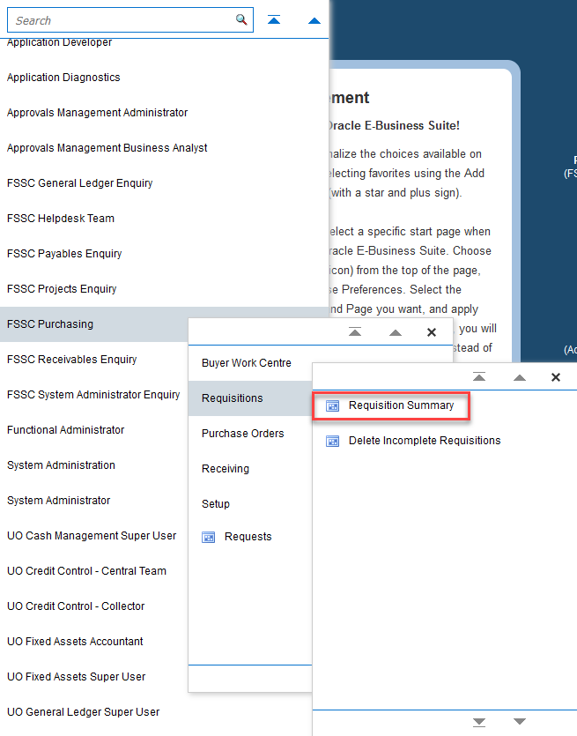

1. At the bottom centre of the screen the following pop up will appear. Click on ‘Open’



1. The Java form will open in a new window on your desktop.



Chrome

1. From the Home Page, select an option that opens a Java form



1. A ‘Save As’ window will open. Click ‘Save’



1. The ‘frmservlet.jnlp’ file will download and appear at the bottom of the Home Page screen. Click on it.



1. The Java form will open in a new window on your desktop.

Mozilla Firefox

1. From the Home Page, select an option that opens a Java form



1. When prompted click on ‘Save File’



1. In Firefox, click on the menu button  towards the top right hand edge of screen and click ‘Settings’

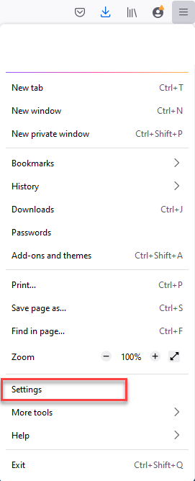

1. Scroll down to the ‘Applications’ sub-section

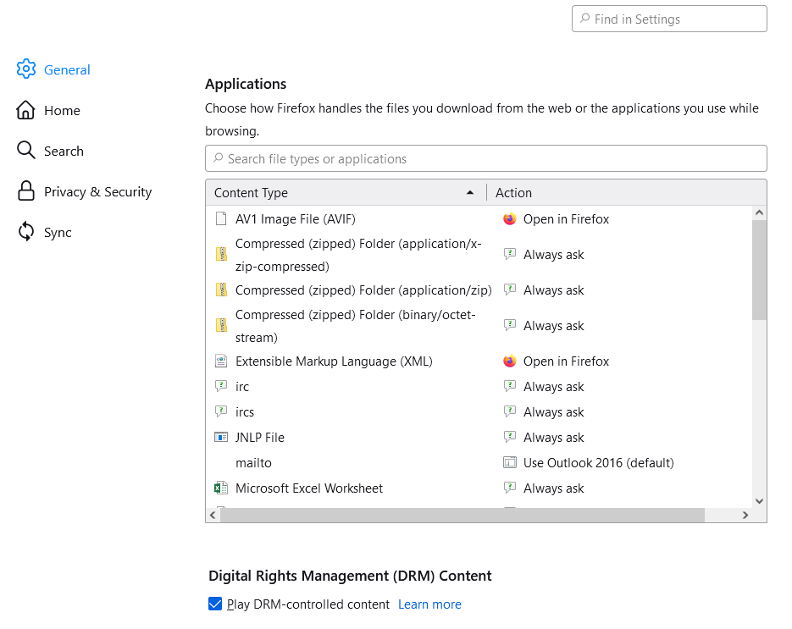

1. To the right of the option ‘JNLP file’, click on the drop down menu and select ‘Use Java(TM) Web Launcher (default)’

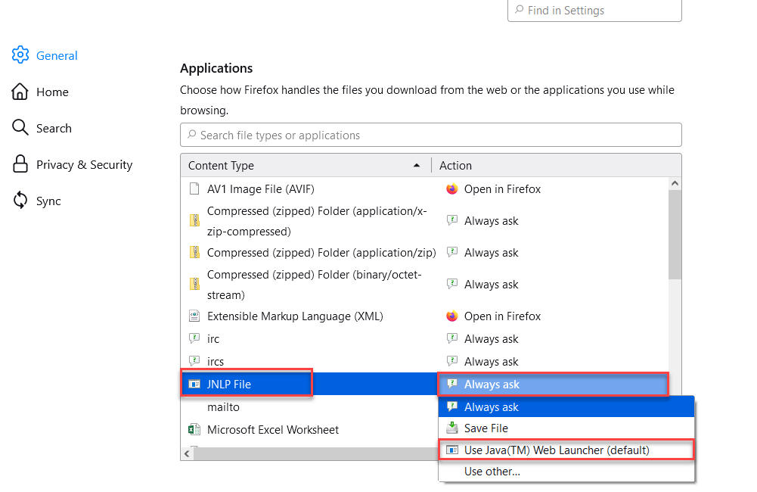

1. Close the ‘Settings’ tab
2. Click on the menu item you initially selected under step 1, e.g. ‘Requisition Summary’. You will see the following window. Click the ‘OK’ button.



1. Click on the Download icon towards the top right hand side of the browser



1. Click on the Folder icon next to the frmservlet.jnlp file name to open the folder.
2. Right click on the frmservlet.jnlp file name and click ‘**Launch**’

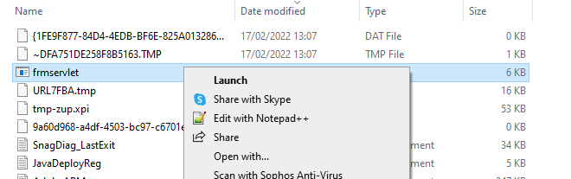

1. The Java form will open in a new window.