Travel Insurance and Registration System (TIRS)
Reviewing/Managing/Approving Applications
Version 2.0

Contents
1 Managing Travel Insurance applications 3
1.1 Logging in / Accessing the System 3
1.2 Manage an Application 3
1.2.1 Review and Validate an Application 4
1.2.2 Approve/Reject (or set other status reason of application) 5
1.2.3 Supervisor Authorisation 6
1.3 TIRS Status Reason Guide: 6

Managing Travel Insurance applications

Logging in / Accessing the System
Access the system here: https://unioxford.crm11.dynamics.com/ and log in with your SSO credentials.

Manage an Application
In many departments, it is the Travel Administrator's role to validate all information that has been entered onto a travel insurance application before a travel manager approves or rejects and application. The system will send the application to the Supervisor for authorisation where requested before it notifies the Travel Administrator of the new application. Please see 1.2.3 for more information on Supervisor Authorisation.
If the information is complete, at least in principle, then the "Travel Administrator Validated" field should be updated in readiness for the Travel Manager to make the final approve/reject decision.
Follow the steps below to validate and / or update the status reason of an application.
Select the application to be reviewed from the home screen - Active Insurance Applications - (see below) or by searching the application (also shown below) by entering the details into the search bar with an asterisk (*) either side.
You can then click on the blue underlined section on the desired trip to open the application.

Review and Validate an Application
If the business process in your department requires a travel administrator to review and validate an application prior to a travel manager approving or rejecting, follow these steps. Before an application is approved, all relevant referrals (e.g. to the Safety Office or Insurance Office) should be made and University procedure followed.
Both the travel administrator and manager role can also be set as the same individual if you do not require a travel administrator to review and validate applications.
The travel manager should review the content of the application and make any necessary referrals where applicable.
Please note that a travel application can be downloaded as a PDF by selecting the Download Application (PDF) button.
Under the Process Management tab (found by clicking … on the taskbar of the application) and expand. If all is as it should be, set the ‘Travel Administrator Validated’ to ‘Yes’ and save the application. This will send an email to the travel manager notifying them there is an application for their review.
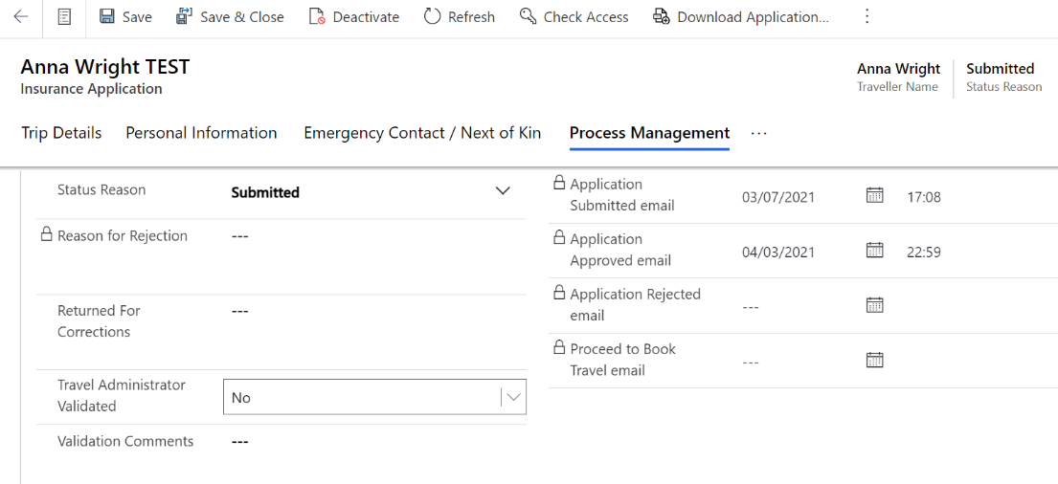

Approve/Reject (or set other status reason of application)
Once the application has been validated (if required) then a travel manager can approve/reject an application.
Open the desired application and select the ‘Process Management’ tab and then amend the Status Reason using the dropdown list.

Set the Status Reason to the desired status.
Please note that only Travel Managers can approve or reject applications but both travel administrators & managers can set all other status reasons.
*Do NOT manually enter any date fields in the Process Management section. These are populated by the system when the emails are generated. The system should now not allow it but please do not attempt to*
Then SAVE the application to finalise the approval. This action will generate an email that will need to be sent manually through the home screen.
You can access the email from the dashboard (home screen), scroll down to ‘Emails’ section and the new approval email should be waiting to be sent (this is system generated and can be edited if needed). Refer to the ‘TIRS – Email Viewing an Editing’ user guide for further information on sending emails through the CRM Dynamics system - https://finance.admin.ox.ac.uk/tirs-information

Supervisor Authorisation
When a user applies for the University insurance they apply via https://travelinsurance.admin.ox.ac.uk which is a different system to TIRS CRM Dynamics and the application site is accessible to anyone with an SSO.
The system allows for either Undergrads, Masters, DPhil and Academics to request supervisor authorisation on their application. This is done by selecting the tick box option that appears on the Traveller Type and entering the supervisors email or SSO.
The system then sends an email to the supervisor with a link to authorise the application. The link will then take the supervisor to https://travelinsurance.admin.ox.ac.uk and they will see a list of all applications to authorise and they will also see any of their own applications here too.
Once it has been authorised by the Supervisor then the system will then inform the Travel Administrator of the application.

TIRS Status Reason Guide:
The table below is a high level description of status reasons, how they are set and information on the email notifications:
Status Reason |  |  | Email Notifications
Status Reason | Description | How Status Reason is Set | Automatic or On Demand | To/CC
Draft | Applied automatically when the application has been created prior to submission. | System Set | N/A | N/A
Submitted | Indicates the application has been submitted. | System Set | Automatic | Traveller & Travel Administrator
Submitted for Referral | Indicates the application has been Submitted for Referral | System Set | Automatic | Traveller & Travel Administrator
Referred to Insurance Team | Indicates that the Insurance Office have been made aware of an application that requires referral. | Travel Admin/Manager | Automatic | Insurance Office & Travel Administrator and Travel Manager
Awaiting Referral Response | Indicates that the Insurance Office have contacted the insurers and are awaiting a response. | Insurance Office | N/A but can be viewed manually by viewing the application in CRM Dynamics | N/A but can be viewed manually by viewing the application in CRM Dynamics
Referral - Insurance Available | Indicates that the Insurance Office have received a response from the insurers that insurance is available. | Insurance Team | On Demand | Travel Administrator and Travel Manager
Referral - Insurance Not Available | Indicates that the Insurance Office have received a response from the insurers that insurance is NOT available. | Insurance Team | On Demand | Travel Administrator and Travel Manager
Proceed to Book Travel | Indicates that the application has been returned to the traveller for the itinerary & accommodation details to be added. | Travel Administrator and Travel Manager | On Demand | Traveller
Returned for Corrections | This status should be set by the Travel Administrator or Manager if any of the given details are incorrect or missing. | Travel Administrator and Travel Manager | On Demand | Traveller
Approved | Indicates an application has been approved. | Travel Administrator and Travel Manager | On Demand | Traveller
Rejected | Indicates an application has been rejected. | Travel Administrator and Travel Manager | On Demand | Traveller, Travel Administrator & Travel Manager.  Insurance Office will be copied in if the application was referred.
Cancelled | Set when a previously approved trip/application has been cancelled. This can be done in the web app or CRM. | System Set (can also be set in CRM) | Automatic | Traveller, Travel Administrator & Travel Manager
Super Auth Requested | Supervisor Authorisation Requested. Set when a user has requested Supervisor Authorisation on their application. | System Set (can also be seen in CRM) | Automatic | Traveller
Super Auth Rejected | The Supervisor has rejected the request to authorise the application. | System Set (can also be seen in CRM) | Automatic | Traveller
Set for Resubmit | Status when an application requires changes and will have to be resubmitted. | Should never be set in CRM. | N/A | N/A

Please note that if someone else creates an application on behalf of the traveller then they will be listed as the ‘Travel Insurance User’ and will be copied in on Approval & Rejected Emails.

