Travel Insurance and Registration System (TIRS)
Emails – Viewing, Editing and Sending a Quick Reference Guide
Version 2.0

Contents
1 Emailing options in TIRS (CRM) 3
1.1 Login to TIRS CRM 3
1.2 Accessing Emails 3
1.3 Opening, editing and sending emails 4
1.4 Running email reports 5
1.5 Further Support 7

Emailing options in TIRS (CRM)
This guide details the steps which should be followed to view and edit emails sent from Dynamics CRM (TIRS).
Certain emails will be created and sent automatically by the system, other emails will be created as drafts and rely on a user to send them. This gives the user the opportunity to review and edit, if appropriate, the email before it is sent.

Login to TIRS CRM
Access the system here: https://unioxford.crm11.dynamics.com/ and log in with your SSO credentials.

Accessing Emails
The emails can be accessed via the CRM Travel Insurance Dashboard (home screen) below the applications. This area will show automatically generated emails that were sent by the system to Travel Administrators & Managers regarding the notification of applications and also shows draft approval emails that are created once an application has been approved. The approval emails can also be edited to include additional information where needed.
This area can also be used to change the order of results for example by filtering Status Reason A-Z as this will show draft emails at the top of the results.

Opening, editing and sending emails
Click the Subject to open the email. This will bring up a new screen and show the recipients as well as the content of the email if you scroll down to the bottom of the screen. The body of the text can be edited and the email can be sent by selecting ‘Send’ on the command bar. Attachments can also be added using the ‘Attach File’ button.
Any email in ‘draft’ mode will need to be opened and sent as they do not automatically send.
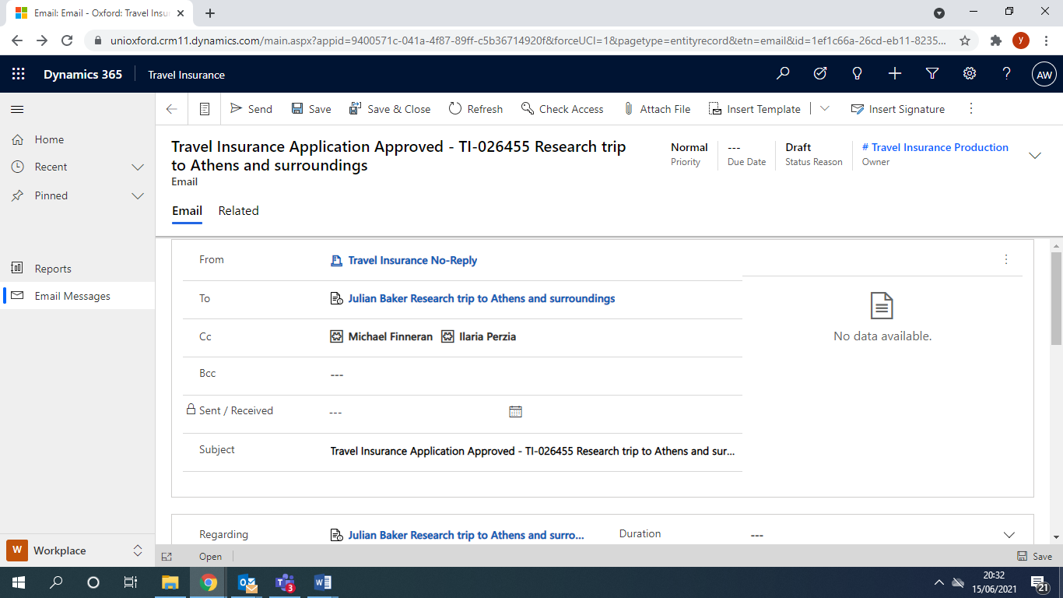
Please note that the system will send the confirmation to the email address listed on the system by the applicant and that if someone else creates an application on behalf of the traveller then they will be listed as the ‘Travel Insurance User’ and will be copied in on Approval & Rejected Emails.
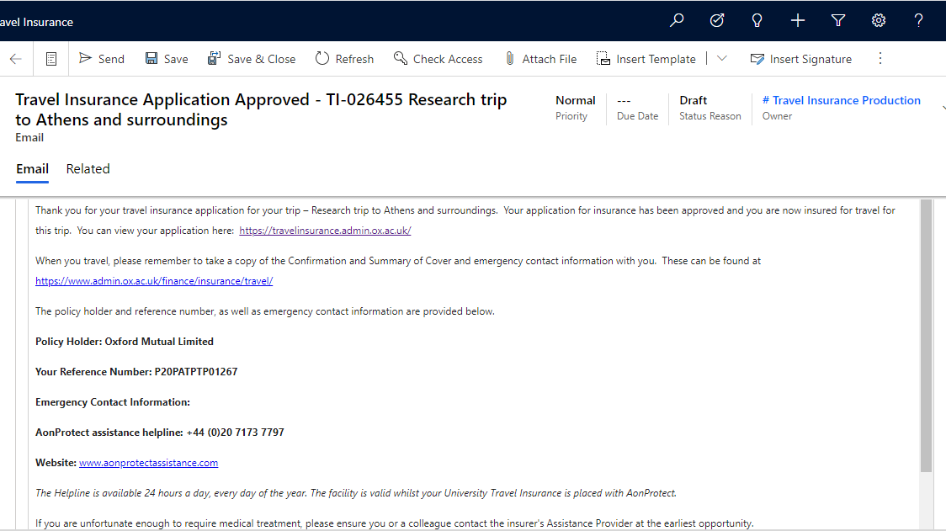

Running email reports
To view all emails and run reports for specific emails, you will need to visit the TIRS CRM dashboard.
From the dashboard, you will then need to change area from ‘Travel Insurance’ to ‘Workplace’

From there, you can switch to ‘Workplace’ and then click ‘Email messages’ on the left hand-side.

You can then filter between all emails, pending emails and received emails etc.
Please note that if you are responsible for multiple departments on TIRS CRM then this will show results for all departments.
If you want to view all emails for a specific travel insurance application, open the application you are interested in, click on the three dots … on the task bar and then select activities.

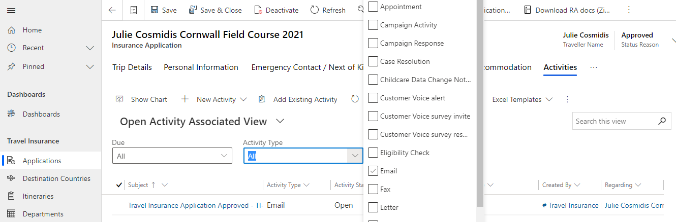
You can then filter to show emails and this will display all emails in relation to the application and the status reason

Further Support

TIRS Email – Bulk Send QRG
This details how to send multiple emails in ‘Draft’ status at one time rather than manually send them each individually
TIRS Fundamentals
For help with basic CRM use including navigation and settings, creating views, searching, creating charts etc.

