Uninstalling the SplashBI add-in
This document details how to remove an existing installation of the SplashBI add-in.
The details below are for uninstalling the SplashBI (Splash Excel Connect) add-in in Windows 10. Although the appearance of your Windows 10 installation may vary, the main steps should be identifiably similar.
If you are in any doubt, or have any issues, regarding any of the below steps, please contact your local IT helpdesk in the first instance.
PLEASE NOTE: depending on your department’s IT policy you may not be able to carry out some or all of the steps below. In which case, please contact your local IT helpdesk in order for them to carry out this task.
Steps to carry out removal of the SplashBI add-in
- Close down Microsoft Excel.

- Navigate to the Search icon on your Task Bar:
- In the search bar, type: control panel

- As you type, the search window should change to show the ‘Control Panel’ App option, plus a number of options available within it. Find and click on ‘Uninstall a program’:

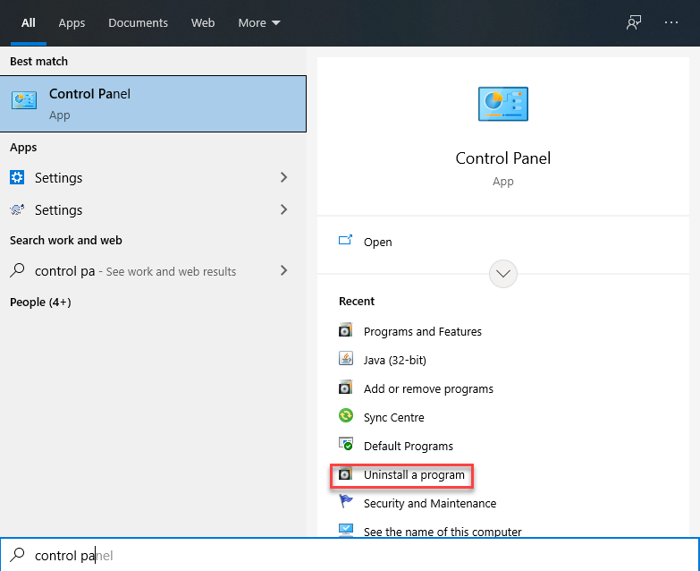
- A window entitled “Programs and Features” should appear:
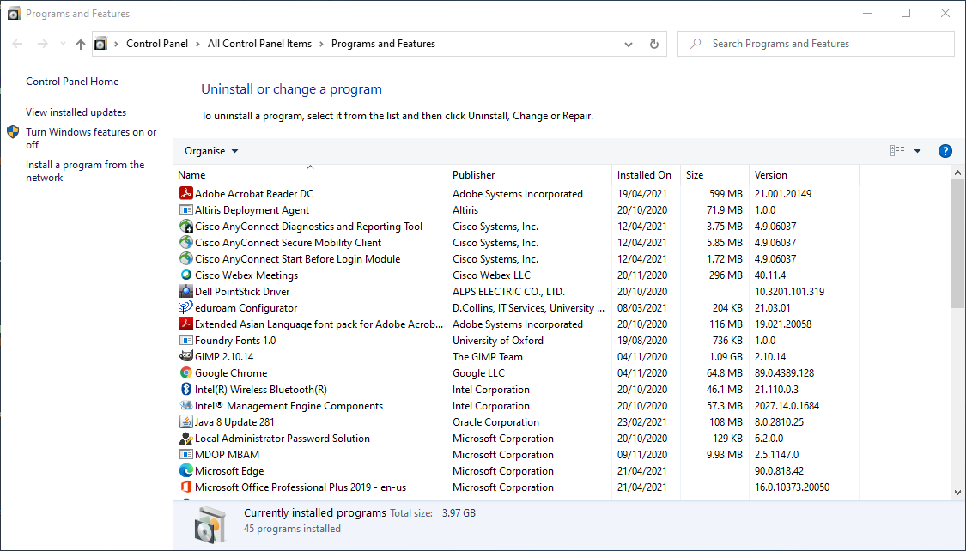
- A list of applications installed on your machine will be listed alphabetically. Scroll down until you come to “Splash Excel Connect”. (The version number will vary, depending on your most recently installed version):
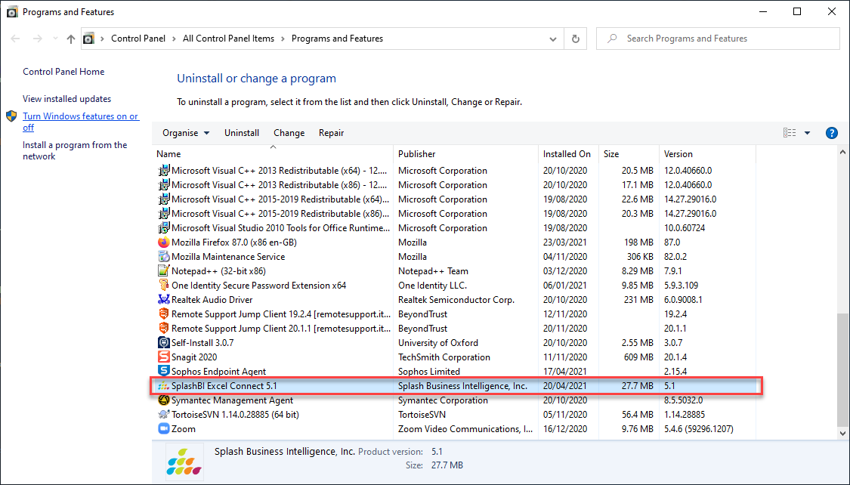

- Click “Splash Excel Connect” to highlight it.

- Click “Uninstall” towards the top of the window:
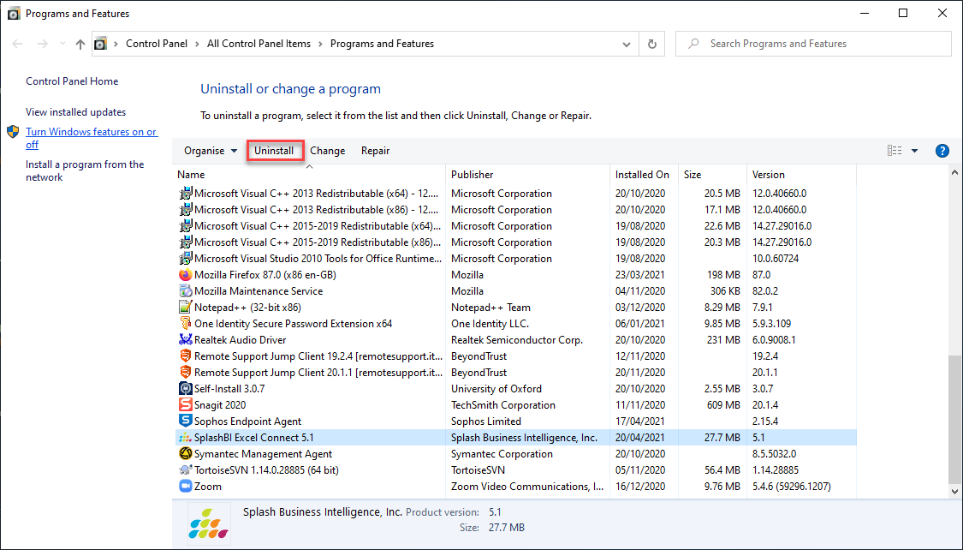
- The following warning will appear:

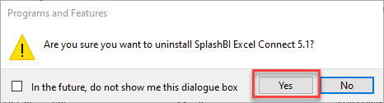

Click ‘Yes’.

- A window will appear for a short time with a progress bar. Once it has closed you should see that the “Splash Excel Connect” application has disappeared.

- Close the “Programs and Features” window.

- You are should now be able to re-install the Splash Excel Connect plugin from the SplashBI homepage.

