(**Department Travel Manager/Travel Administrator Access**)
A formal request is needed for access to the CRM Dynamics system (TIRS back-office) for Travel Managers and Travel Administrators wanting to view, approve and manage travel applications on behalf of their Department/Business Area. The request form can be accessed here - service request.
Once access is granted the CRM Dynamics system (TIRS back-office) can be accessed here
You must select the second option from the drop-down menu to sign in.
Once signed in, you will need to set up your access as a Departmental Contact.
This Process User Guide will show you how:
Sections:
- Select Department
- Review and add Departmental Contact
- Edit Departmental Contact
- Do Not Use – Menu Areas
- Adding a Department to TIRS
- Adding a generic Department Email to TIRS

- Select Department
From Start Page (or Home Page)
Select Departments from menu at left side of screen:
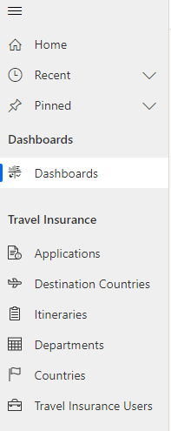
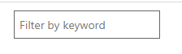
This will show Active Departments
To locate your Department, use the search function at the right side of the screen:

When you have located your Department, select it by clicking onto the hyperlink to access:
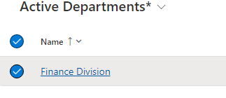
For example:

- Review and add Departmental Contact
The Department Screen will show
- The main contact email address for the department (where applicable)
- The division the department is attached to
- List of Departmental Contacts already in place
Once you can see the Departmental Contacts within your Department, you will note that just above the list to the right side of the screen you have an option to add a new Departmental Contact:
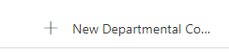

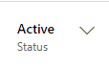
By selecting this option, a new screen appears:
In the top right corner, you will note the status of the contact:

The remainder of the screen looks like the below:
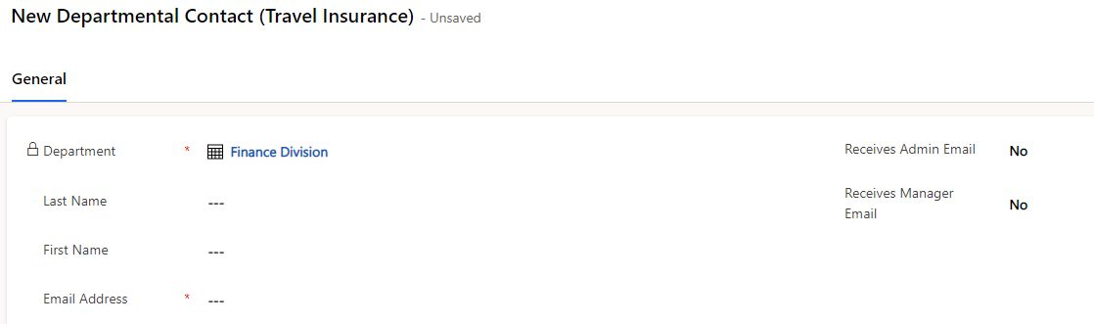

Note – Your Department Name will be displayed against Department
To Add the new Departmental contact, you need to:
- Add the last name, first name and Oxford University email address for them
- Select whether you want them to receive Administrator emails
- Select whether you want them to receive Manager emails

For the last 2 options:
- Administrator – Able to validate applications – Change No to Yes (hover over No and drop-down menu appears)
- Manager – Able to Approve applications - Change No to Yes (hover over No and drop-down menu appears)
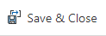
Once you are happy with your selections – select the option at the top of the screen to

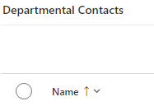
- Edit Departmental Contact
On the Department screen, at the left side of the existing Departmental Contact
you would like to edit, select the record by clicking on the circle next to the name
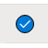

When you have done this – you will see that the menu line to the right-hand side, above the names provides the following options:
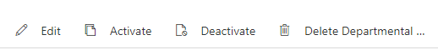

- Edit – enables edit of the existing record.
- Activate – activates a previously deactivated record – when someone has returned from leave and resumes duties.
- Deactivate – deactivates a previously active record
- Delete Departmental Contact – deletes the entire record from the system.
Note - These 4 options should only be used when needed.
Option A is Ideal for when someone has a new email address, last name or when you would like to change which types of email they receive.
Options B & C - are designed for when someone goes on/returns from long term leave so their access can be temporarily deactivated then reactivated.
When deactivating it is important to set the two email questions to No so that the person does not continue to receive emails during their absence.
The Department must then reset the option when reactivating.
Options A-C can be reversed by the user going back into the record and updating again
Option D – deletes the contact and is a permanent system change. As such this should only be used if someone has left the Department permanently.
The system will always ask if you are sure when deleting. Only select yes if you are sure.
- Do Not Use Menu Areas:

Please Do Not Use the menu options at the top of the screen as these affect the entire department record and should only be used by Insurance Office and/or Dynamics Team.

In Department Screen these look like:
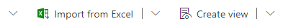

In Departmental Contact Screen these look like:
Especially avoid selecting –
- Delete - in either menu
- Deactivate in Departmental Contact menu
Other addition requests:
- Adding a Department to TIRS
Selecting new on the menus may appear to add a department record.
However, this will not register with CDM Dynamics as a system change.
As such, you will need to generate a service request and specify that you would like to add a new department.
The request form can be accessed here - service request.
Once confirmed as added, the process to add departmental contacts to the department can then be followed.

- Adding a generic email address to your Department
If you have multiple Travel Administrators and Managers then you can set up a generic email address to have the notifications sent to first
To do this:
- Contact the Financial Systems Service Desk at financials@admin.ox.ac.uk to generate your new email address.
- Then once you have your email address (user ID) you can arrange the TIRS access service request for the email address as per the link in the section above.

