SplashBI – Scheduling Reports

Splash scheduling now includes the provision for the “Last day of the selected month(s)” under the Advanced Schedule option.
Existing schedules can also be paused and resumed as required.

Last Day of the Selected Month(s) - advanced schedule option
- Navigate to the report and enter your parameters as normal, then click Schedule
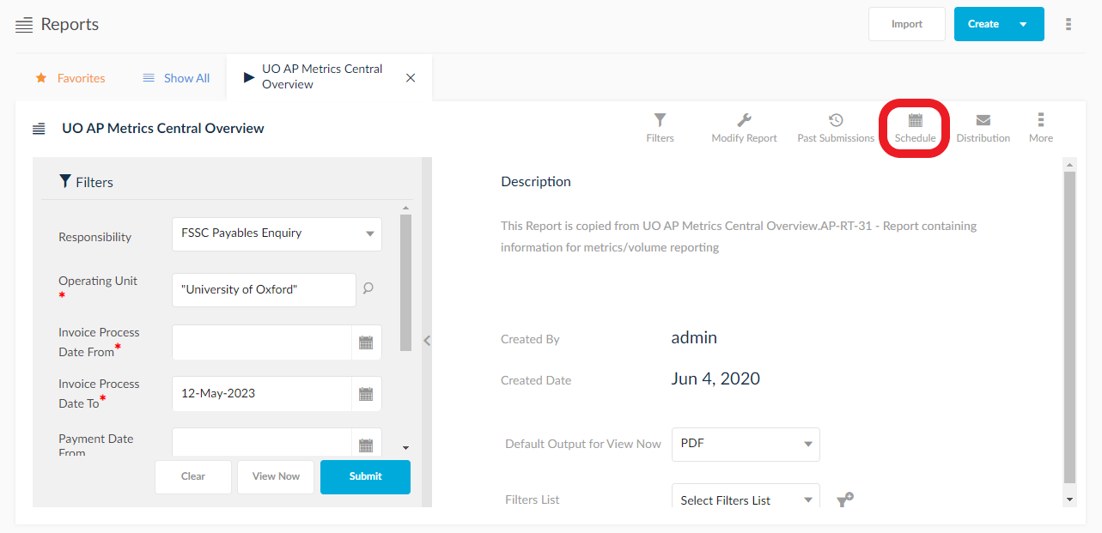
- Select the Advanced Schedule option.
Complete the schedule name and start/end dates as normal.
(The end date should not be left blank.)
The option for Last Day of the Selected Month(s) falls under the On parameter.
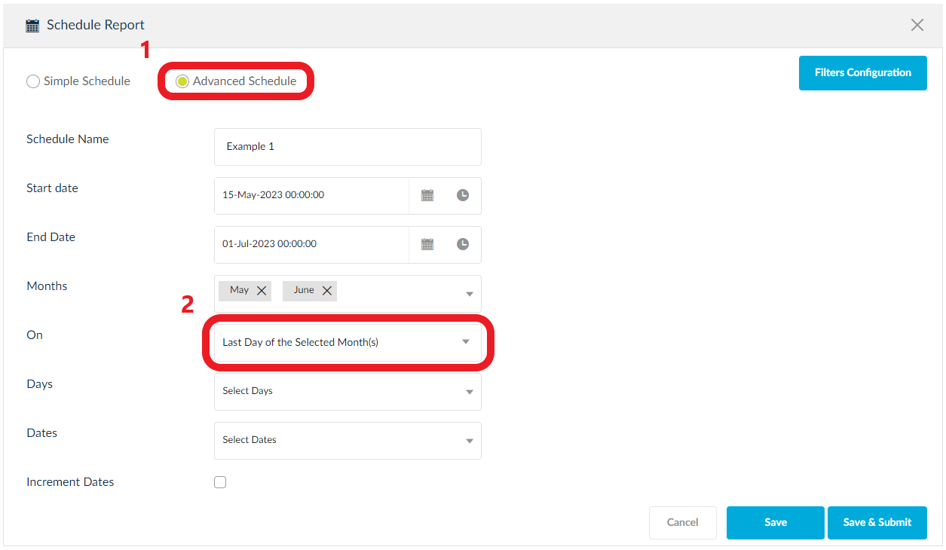
Note that the following error message will present if any months are selected that fall outside of the start and end date.
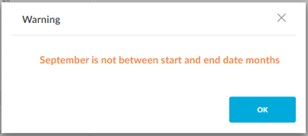

The option for Last Day of the Selected Month(s) falls under the On parameter.

Amending schedules
- To amend a scheduled report, first navigate to Reports then the 3 dots -> Scheduled Jobs
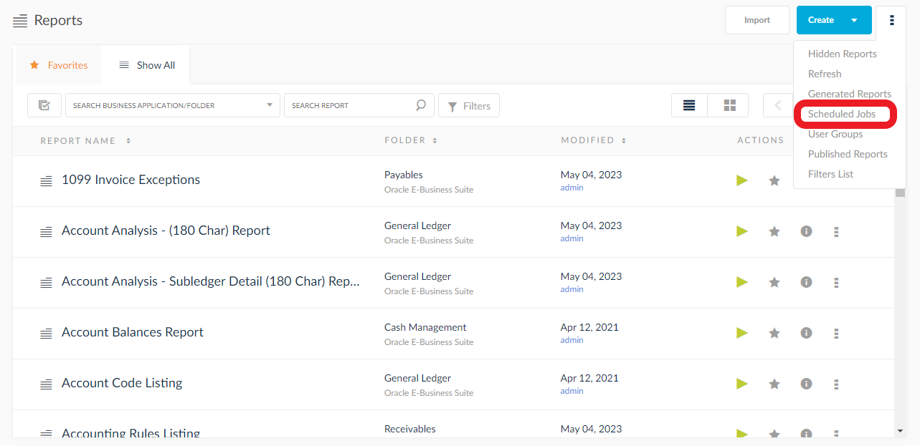
- Click the pencil Edit icon to amend the schedule.
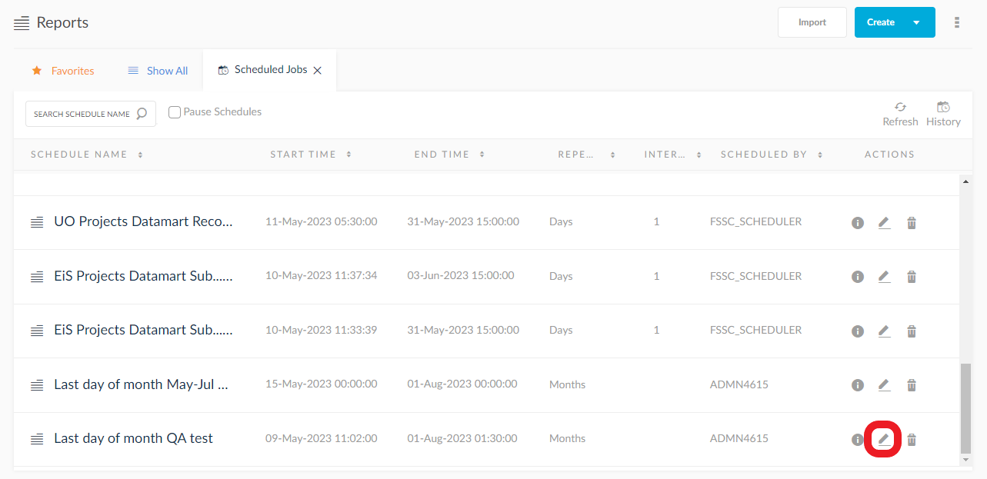

- Amend the schedule parameters as required, then click Save
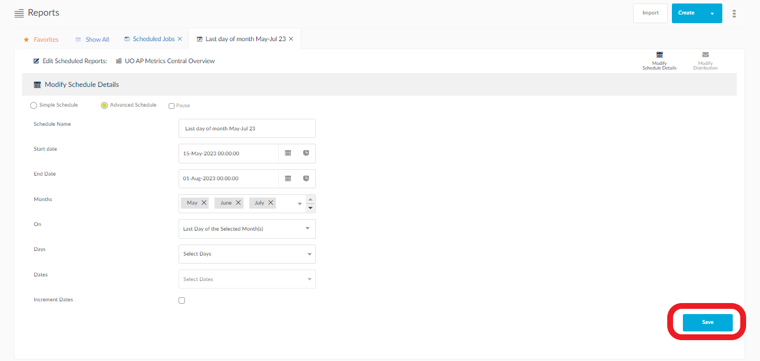

Pausing schedules

Pausing a specific schedule
- To pause a specific schedule, first navigate to Reports then the 3 dots -> Scheduled Jobs

- Click the pencil Edit icon to amend the schedule.

- Select the Pause Schedules checkbox.
Schedules can be paused indefinitely by selecting the Manual option, however they can be paused for a set amount of minutes, hours, or days.
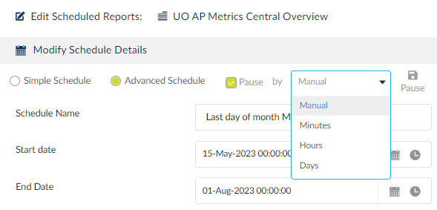
Click Pause to complete the action.
Do not click Save. This is used only to commit an amendment to the schedule.
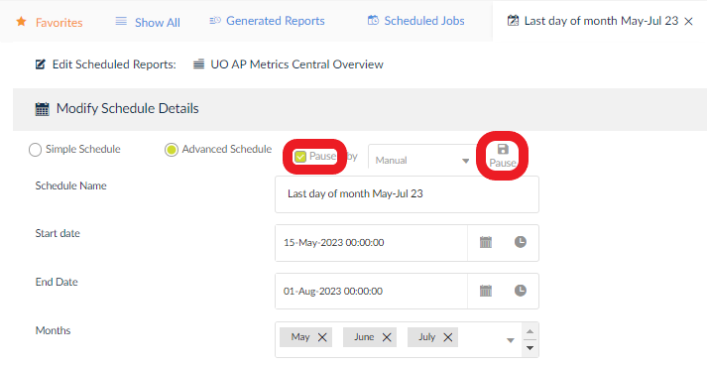
- To confirm a schedule is paused, navigate to Scheduled Jobs. Currently paused schedules are highlighted with a yellow hue and small pause icon.
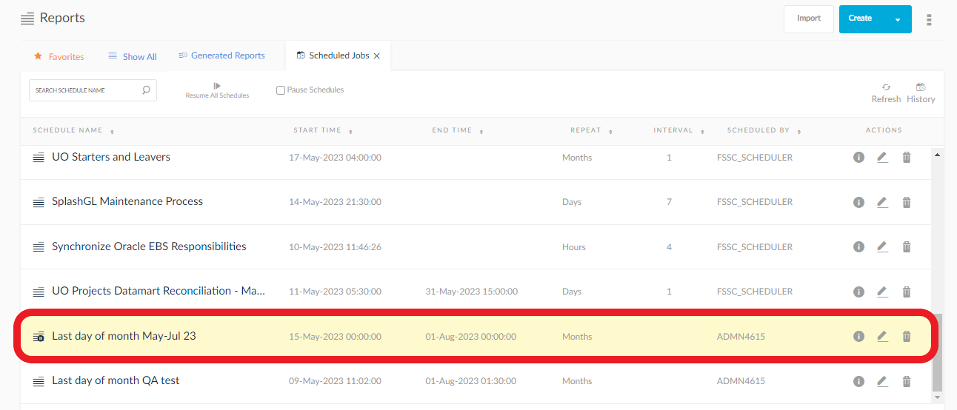

Pausing multiple schedules

- To pause multiple schedules, first navigate to Reports then the 3 dots -> Scheduled Jobs
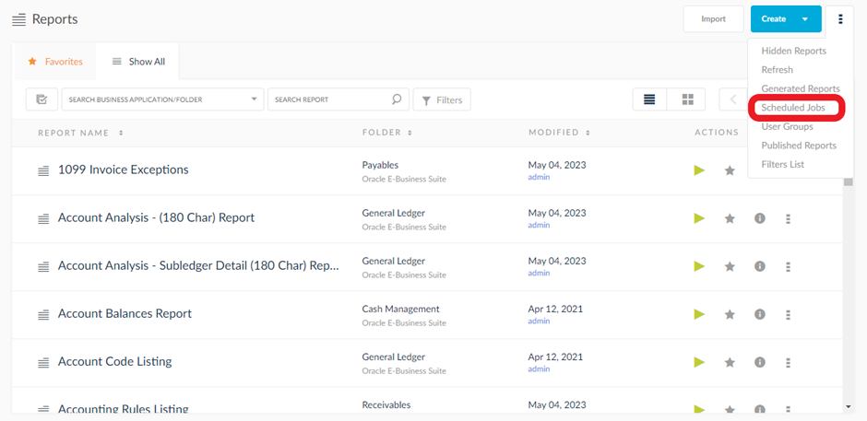

- Select the Pause Schedules checkbox.
From the drop-down menu, choose the required pause duration, noting that this will be applied to all selected schedules. As a default, all schedules are highlighted.
Click Pause to confirm
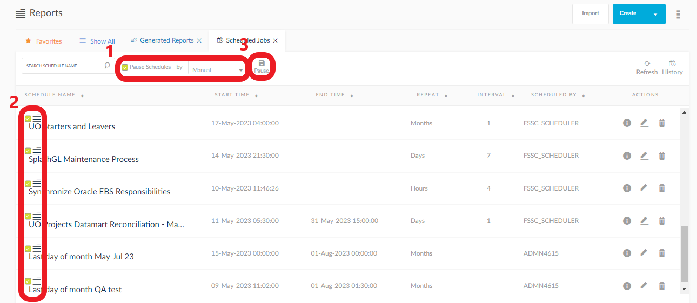

Resuming a specific schedule

- To resume a specific schedule, first navigate to Reports then the 3 dots -> Scheduled Jobs
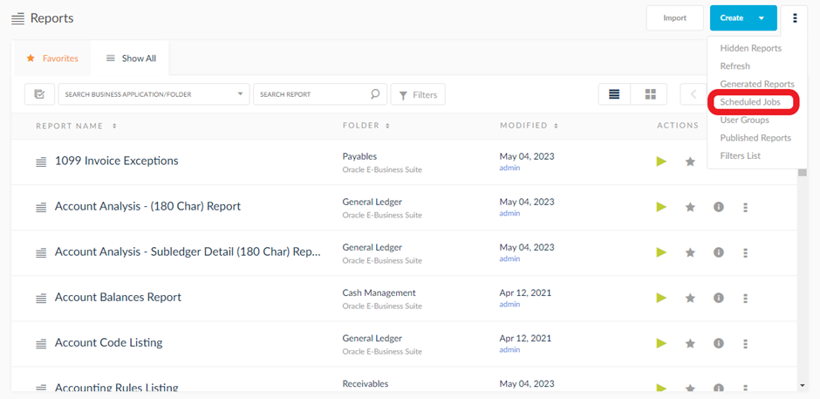

- Click the pencil Edit icon to amend the schedule
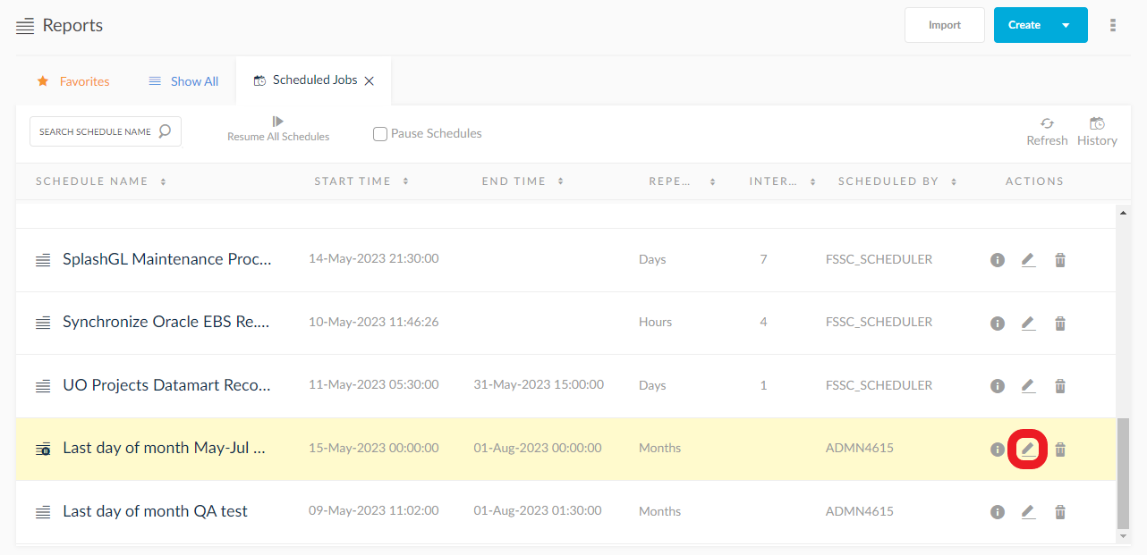

- Select Resume All Schedules
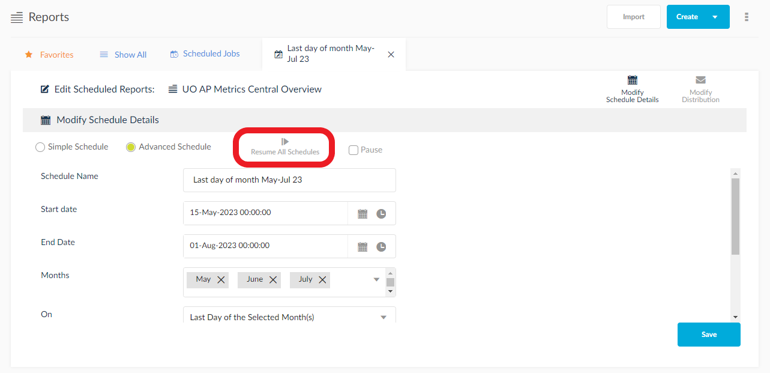

Resuming all schedules

- To resume all schedules, first navigate to Reports then the 3 dots -> Scheduled Jobs
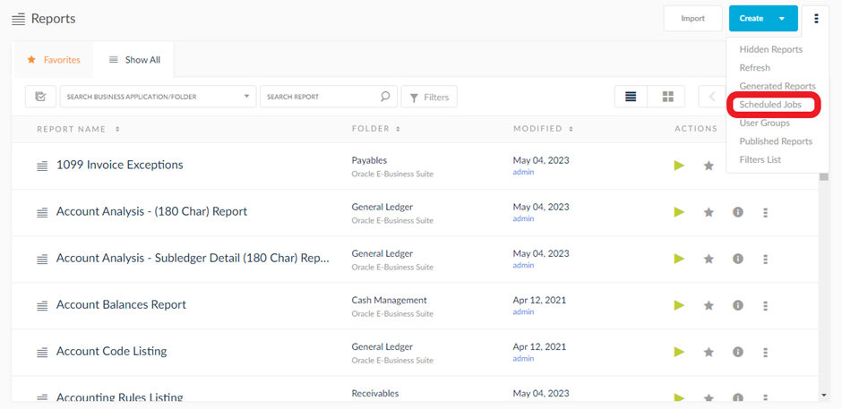

- Select Resume All Schedules
