SplashGL - Exporting Distribution Templates for the SplashBI v5.4 upgrade

In preparation for the SplashBI upgrade to version 5.4, Distribution Templates used in SplashGL will need to be exported before June 15th 2023.
These exports will be saved locally by users and uploaded to SplashGL once the upgrade is completed.

How to export Distribution Templates

- Log in to SplashGL, select Burst -> Distribution Templates
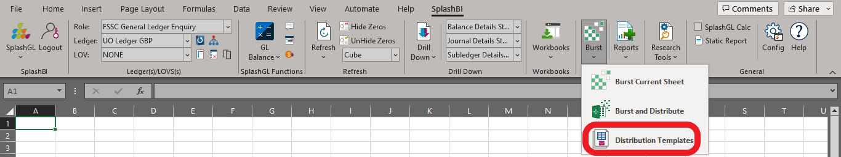

- Find the template you wish to export and click the pencil icon to Edit
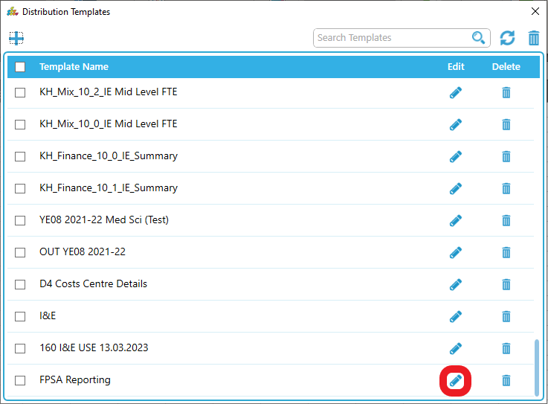

- Select Download Excel to export the file
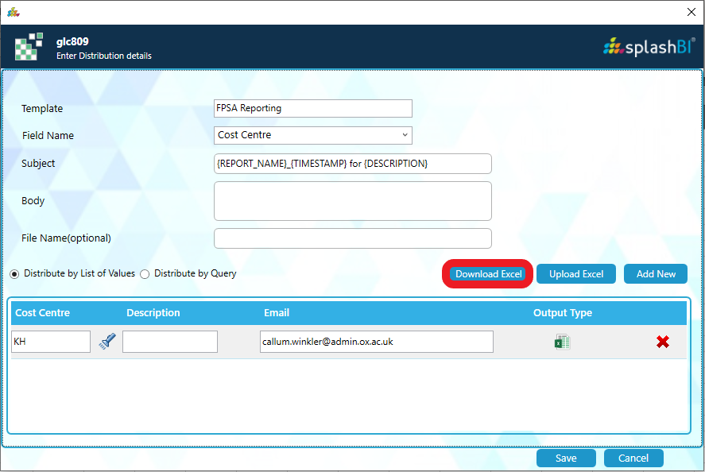

- Navigate to an appropriate folder and click Save
A message will appear to confirm the file has been exported successfully
