SplashGL – Creating Templates for Bursting and Distribution

To Burst and Distribute in SplashGL, respective templates must first be created for each aspect of the functionality.
The Bursting template is populated with information related to the depth level.
Unique Bursting Templates must be created for each report. Please refer to step 3 for more info.
The Distribution template is populated with information related to the recipients, and the specific Cost Centres they’re responsible for.

Creating a Bursting Template
1. First navigate to Burst -> Bursting Templates
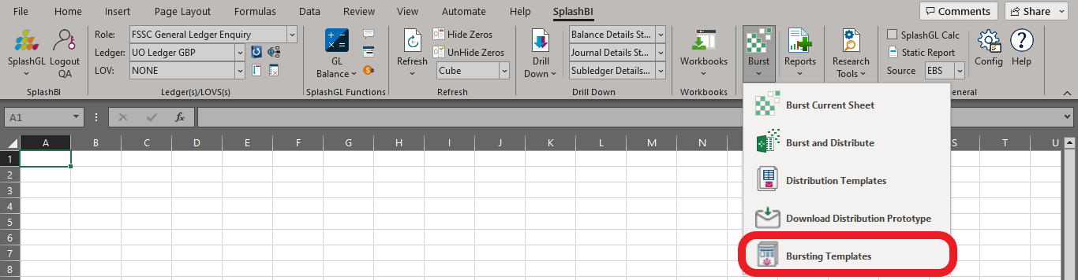

2. To add a new template, click the plus icon in the top left of the box
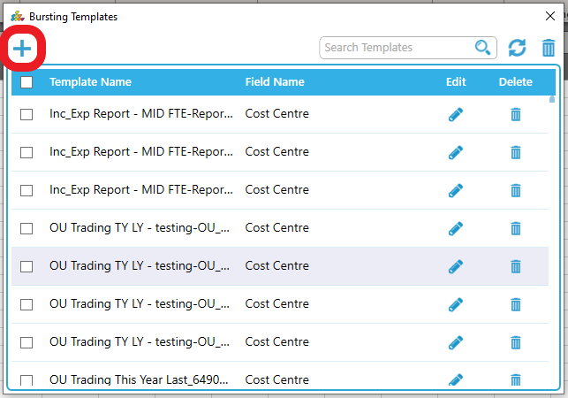

3. Enter a Template name, select the appropriate Bursting Field (the Hierarchy will automatically populate)
-> Enter the reference cell for the Bursting Field
-> Select the desired Bursting Direction as well as the Depth Level from the drop down.
-> Check the box to Include All Levels, if required.
Click Create to confirm
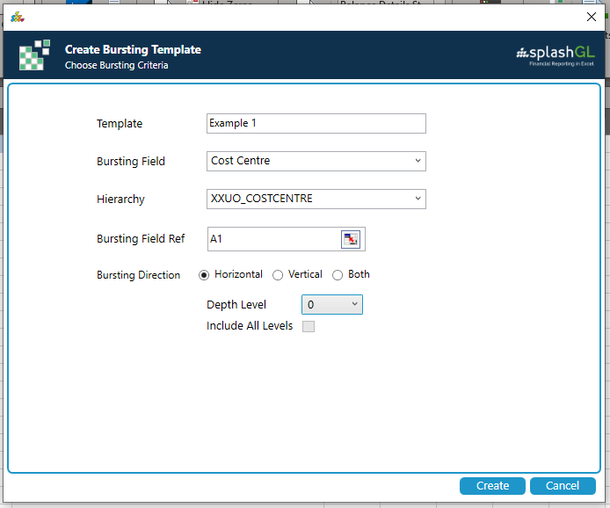
Please note that a unique Bursting Template is required to be created for each report.
If a Bursting Template is first used to burst a particular report, an error message will appear if the same template is used on a different report.
“Bursting template cannot be applied since none of the bursting template sheets are found in the workbook”
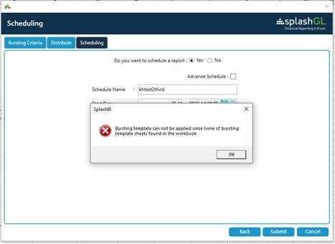
Once the template has been created, you can enter a relevant search value to filter the list.
(Note that there is the option to edit a created template by clicking on the pencil.)
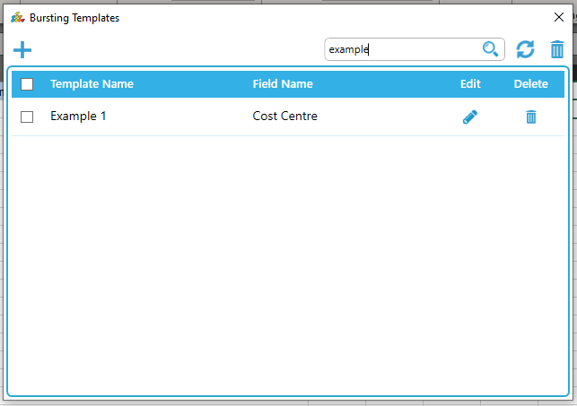

Creating a Distribution Template
1. First navigate to Burst -> Distribution Templates
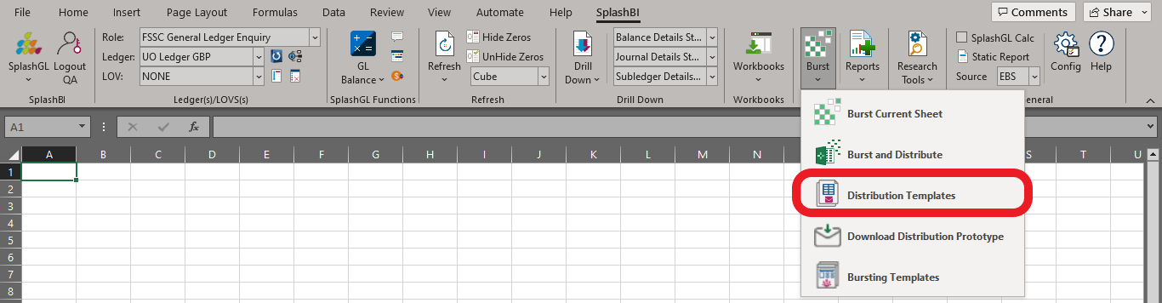
2. To add a new template, click the plus icon in the top left of the box
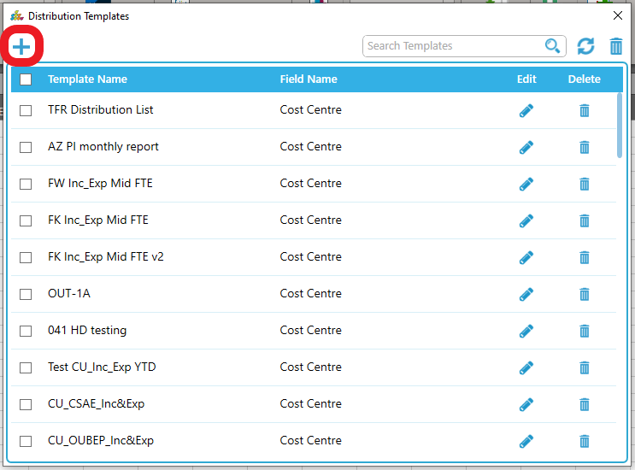
3. Enter a Template name, select the appropriate Field Name.
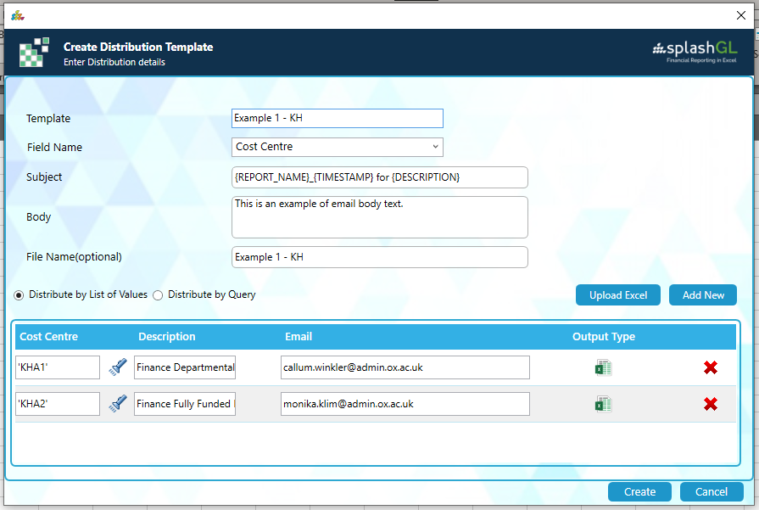
4. Enter the Subject, Body, and File Name (if required) to be included in the email output.
5. Enter the relevant information pertaining to the Field Value, Description, and email address of the recipient. (To add additional entries, click Add New to create another line)
If you have a long list of recipients, you can create an Excel file containing all the pertinent details. Under the Burst menu (step 1), select Download Distribution Prototype, then populate the rows with the appropriate information and save the file. At step 5, click Upload Excel and locate the file.
Please note that multiple entries aren’t accepted for both the manual addition and Excel upload.
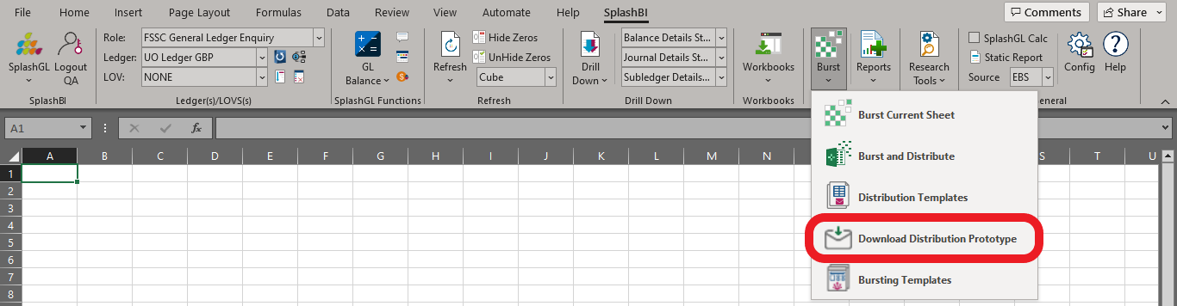
6. Click Create to confirm. The below message will present if completed successfully.
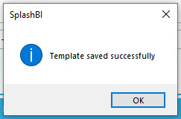
Once the template has been created, you can enter a relevant search value to filter the list.
(Note that there is the option to edit a created template by clicking on the pencil.)
